**Lesson Notes**

1. What is the main purpose of an Operating System?
2. What is the difference between Operating System Software and Use Application Software?
3. What is the difference between Operating System Software and Computer Hardware?
4. What are the main parts of an Operating System?
5. What are some popular operating systems?

**Reference Diagram**

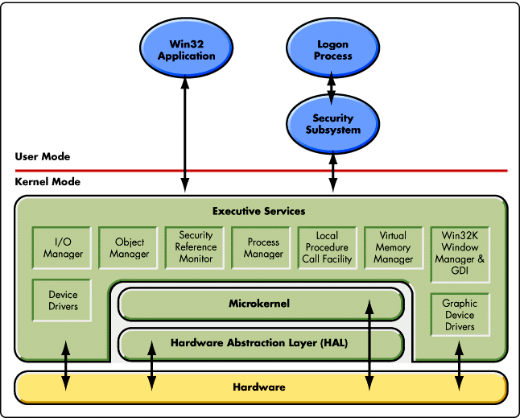

**Student Questions**

1. What is a device driver?
   1. Provide a brief summary
   2. List some devices that require a device driver.
   3. Provide a label on the reference diagram for the location of a device driver for your graphics card.
   4. Provide a label on the reference diagram for the location of a device driver for a locally attached printer.
2. What is a DLL?
   1. Provide a brief summary
   2. Explain how DLLs are related to user application programs
   3. Provide a label on the reference diagram for the location of a DLL
3. What is a windows manager?
   1. Provide a brief summary
   2. Explain how a windows manager is related to user application programs
   3. Provide a label on the reference diagram for the location of a DLL
4. What is the windows task manager?
   1. Provide a brief summary
   2. List and explain four (4) types of system information provided by the task manager
   3. Provide a label on the reference diagram for the operating system components related to each type of information.